**How to drive DC motor using L293D with CHIP**

* **Objective**

In this tutorial I will show you how to connect motors to your CHIP. What we plan to do is safely connect one or two motors to the CHIP with as few components as possible. Once we have the electronics put together on the breadboard, I will show you how to control them easily using Python to first make the motor spin, and then add some control to change the motor direction so we can go backwards.

This guide will require a careful eye to catch any mistakes, and a bit of courage, especially if you are new to the GPIO connectors. I would like to stress I am not responsible for any damage caused to your CHIP and/or components.

* **Equipment**

CHIP, breadboard, L293D motor drive chip, a few cables, two 6V GM3 DC motors, voltage booster, and voltage regulator.

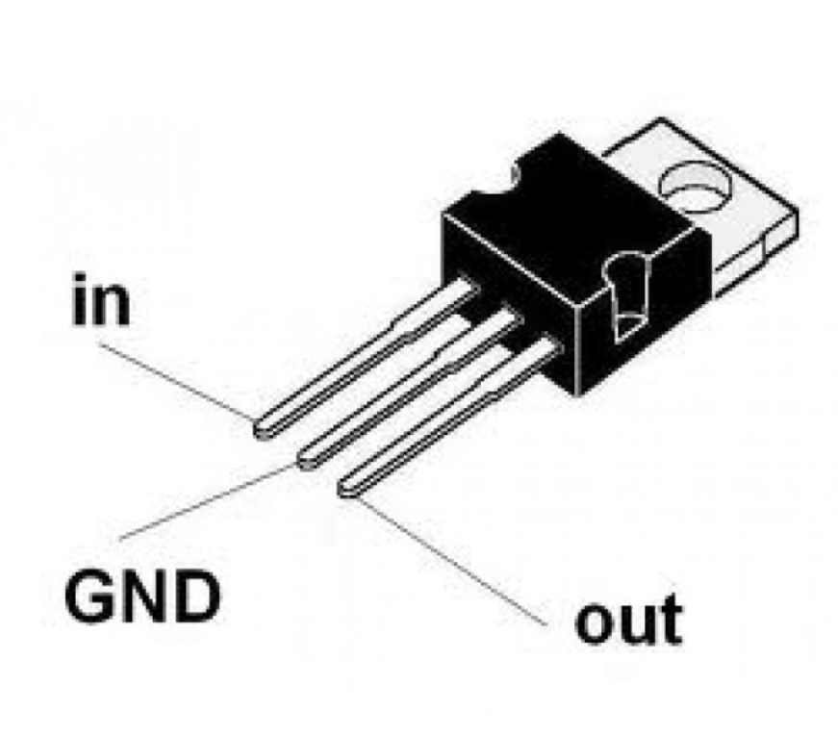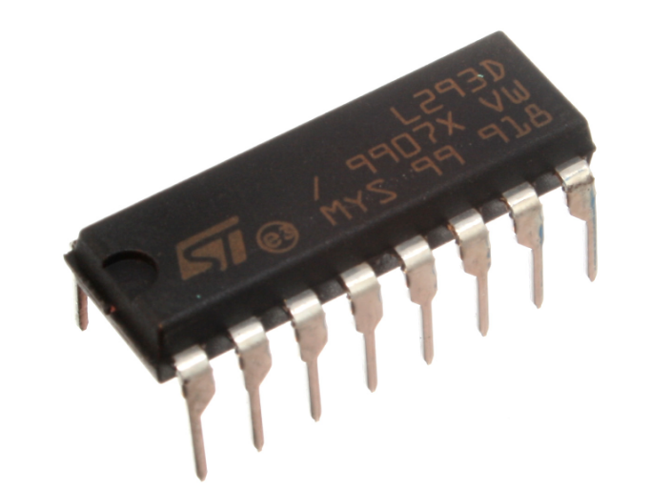

Voltage Regulator L293D Chip

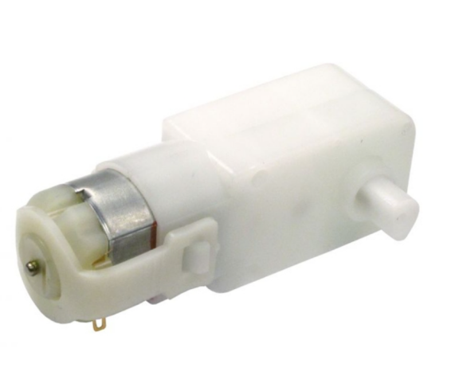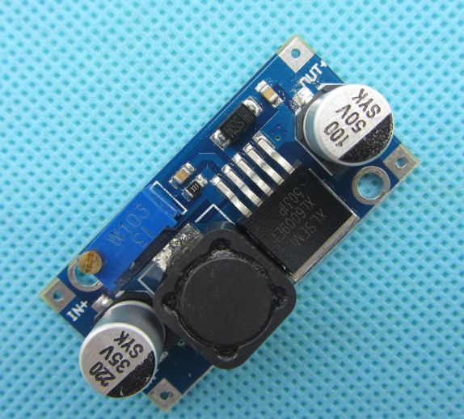

GM3 Motor Voltage Booster

* **Assembling the Circuit**

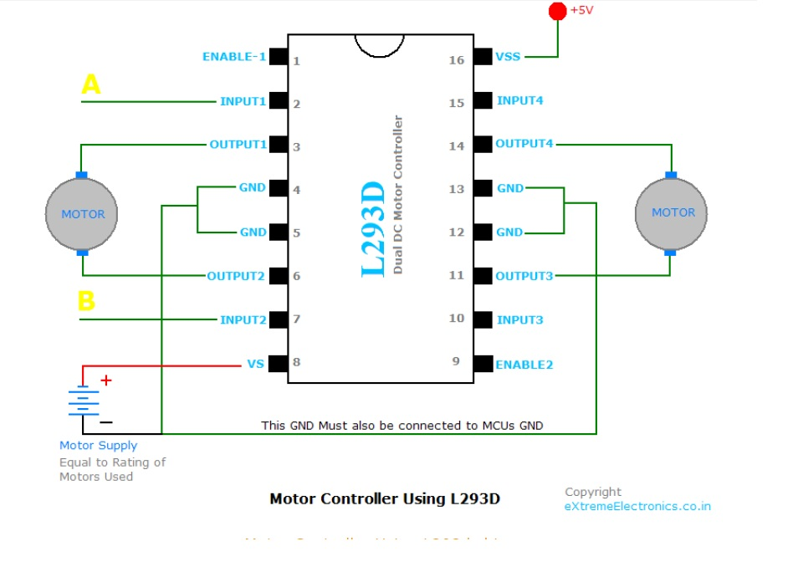

-Connect motors to input pins of L293D

-Connect digital output pins of CHIP to 4 inputs of L293D. (Pin No is up to you. I chose “CSID3” and “CSID5” as my output pins for one motor.)

-Connect digital output pins of CHIP to “Enable 1” and “Enable 2” pins.(Again, pin No is up to you, I chose “CSID7” to connect with Enable 1 for one motor)

-Connect voltage regulator to convert 12V to 6V

-Connect regulator with voltage booster

-Connect power and ground pins

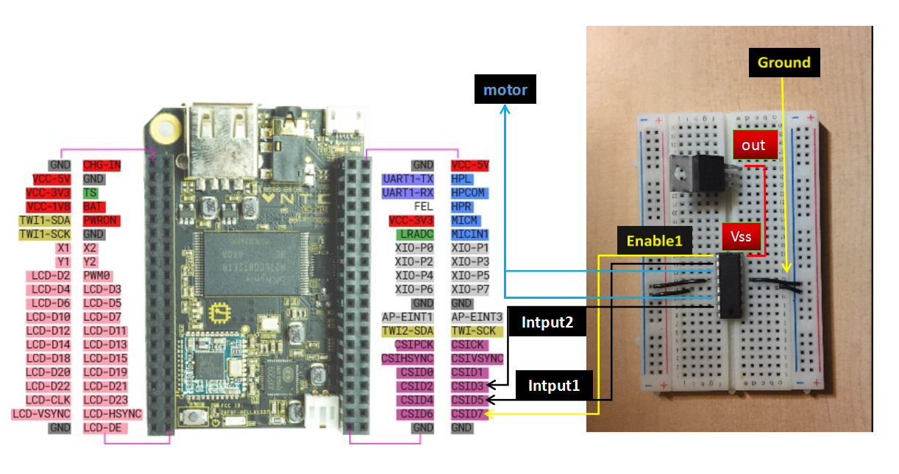

Image 1: Connection of one motor, L293D, and regulator

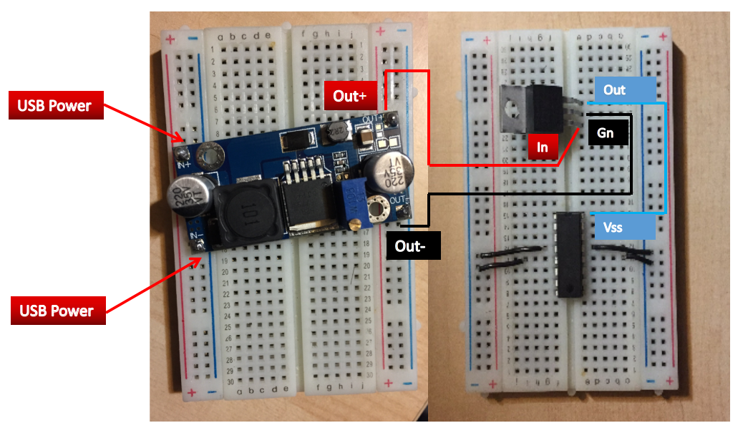

Image 2: Connection of voltage booster, L293D, and regulator

* **Testing**

In order to get the motors to work we use python program called MOTOR to test it. You can find the python program on <https://github.com/weetinygit/Romibo-V8>

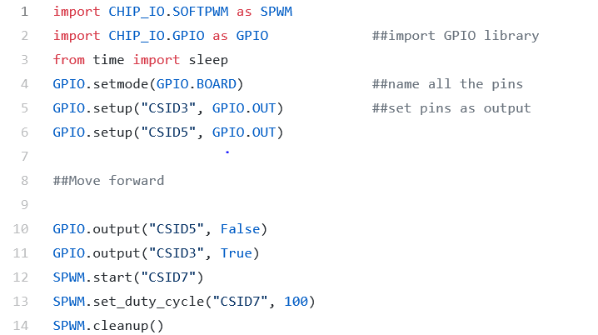

-Test the program by typing “cd /home/chip/Romibo-V8/python” to change the directory, then type “sudo python MOTOR.py” to run the program in Linux.

* **References**

Arduino example:

<http://communityofrobots.com/tutorial/kawal/how-drive-dc-motor-using-l293d-arduino>

Raspberry Pi example:

<https://business.tutsplus.com/tutorials/controlling-dc-motors-using-python-with-a-raspberry-pi--cms-20051>